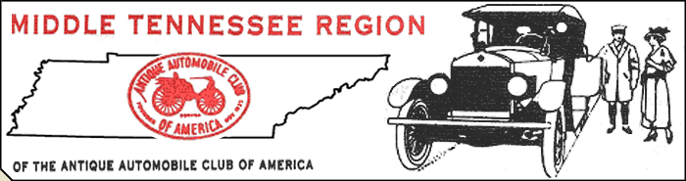
Glenn Edwards, President ~ Dr. Roger McKinney, Vice-President ~ Read Majors, Secretary ~ Marc Humes, Treasurer
615- 483-2661

June 2010

Well we finally got our Wilson Bank Mt. Juliet Show accomplished. It was a success considering biblical flooding, two postponements and even the threat of rain once again on the day of the show. We had nearly 100 cars, everybody got a trophy and a good time was had by all! The Granville Heritage Day Show was a monster. 281 cars, good weather, people galore and great food. The only negative was a shortage of judges. We try to keep our judging teams comprised of MTR AACA members only . There were almost 300 cars, but just a handful of members were available to judge. We simply must have a good showing of hardworking members at every event, so please come out and support the team.

“Welcome” to new members: Paul and Mary Harvey, Ulf and Lori Lindskoug and James Burton. Glad to have you in Mid-TN and we look forward to getting to know each of you!

At the meeting Sunday a motion was made and approved to explore the possibilty of hosting a Dual Meet in 2014. This means a Grand National Meet (held on Friday) and a regular National Meet (held on Saturday.) We have an excellent reputation with the national office and they are likely to approve our request. As most of us know, this is a huge undertaking and after the tremendous success of our Southeastern Special Spring Meet in 2009, we want to continue our standard of excellence. More on this as the situation develops.

UPCOMING EVENTS:

- Founder's Day at Fiddler's Grove – Saturday June 26th 10 AM til 4PM. We need cars for display around the Grove. Our club will be having an Ice Cream Social at the clubhouse during the event. Bring your ice cream freezers to make the old fashioned good stuff. If you haven't got a freezer, just bring some other high carb goodie that will go well with homemade ice cream ( what doesn't.) It'll be a fun day with good food and good friends!
- Murfreesboro Show – Wilson Bank show at the branch office on Hwy. 231 in Murf is Sunday June 27th. Our newest show has proven to be a popular attraction with lots of cars, music and fun. We need all hands on deck for this one!
- As you know from reading your AACA Magazine, the 75th Anniversary Celebration of the AACA is being held in Louisville June 30th through July 3rd. The National Meet is Saturday the 3rd and it is being held indoors. It's a biggie you don't want to miss.
- Our next regular meeting is July 11th. COME TO THE MEETING AND GET INVOLVED. Seeya' there.

